

Assessment - 2

Data and Visualization for
Business
(BUSA8090)

Name: Jeebak Sabu
Student ID: 48085847
Word Count: 1497

Table of Contents

Introduction 3
Data Preparation, Transformation & Cleaning 4
Visualizations & Findings Interpretation of Patterns 4
1. Annual Road-Crash Counts (2001 – 2023) - Time-Series Line Chart 4
2. Map visualisation to illustrate the geographic distribution of road crashes across 5
3. Crash severity each year 5
4. Crash severity by hour of the day 6
5. Severity distribution across different crash types 7
Trends & Anomalies 7
Ethical Principles Applied 8
Conclusion 9
References 10

Introduction
Queensland’s open-data file records every police-reported crash from 2001 to 2023, with about 394,000 rows and 52 variables including time, location, severity, and road context. Raw tables are messy, thus structured cleaning methods were used to produce an analysis ready dataset. Five specific images then transform the numbers into insight:
- The twenty-year line chart shows total crashes and indicates the 2011 reporting hiatus.
- Kernel-density maps identify coastal and south-east hotspots.
- The severity mix varies by year, with fluctuating proportions of crash severities
- Hourly stacked bars show peaks in severe outcomes.
- Crash type vs severity heat map identifies type of crash and its severity.
Each visual is examined for patterns, abnormalities, and potential causes before being linked to practical countermeasures in law enforcement, engineering, and education. Every step of the process is guided by ethical standards such as accuracy, privacy, and clear, bias-free design, which transform a large administrative log into useful road-safety intelligence.

Data Preparation, Transformation & Cleaning
The raw crash_incidents.csv (52 columns, 393 879 rows) was loaded in pandas with mixed-type warnings turned off. Quick ‘head()’, ‘info()’, and ‘description()’ calls confirmed complete coverage of dates, severity, and road factors, while identifying a few “object” fields that should be numeric. A duplication check revealed none and each entry has a unique Crash_Ref_Number. Missing values where uncommon six descriptive fields were marked with the label “Unknown”, and 598 blank latitude/longitude cells were left blank rather than created so it does not create any false information. The data was then standardised, and Crash_Month strings were stripped and mapped to integers 1-12, all numeric-looking fields were converted to proper int or float with invalid stubs set to “NaN”, and the remaining content was preserved as categorical strings. The cleaned data was exported as CrashData_clean.csv, which is the source for all subsequent visualisations.

Visualizations & Findings Interpretation of Patterns

Annual Road-Crash Counts (2001 – 2023) - Time-Series Line Chart
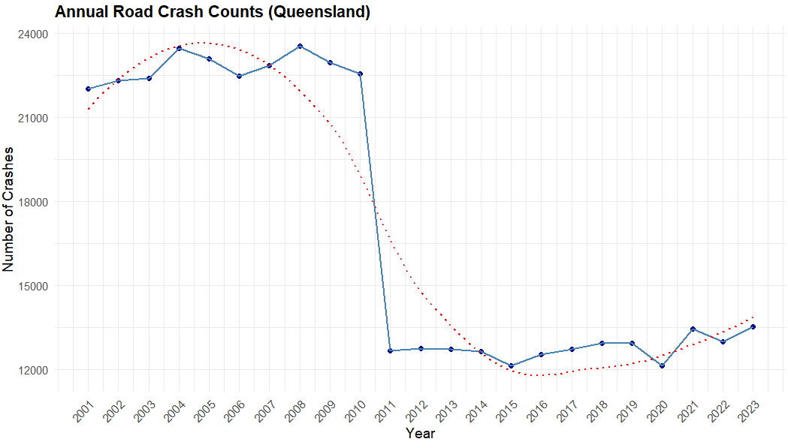
A simple annual line chart depicts collision numbers from 2001 to 2023, with blue dots representing each year’s total and a connecting line to highlight shifts. A red dotted smoother is placed atop the data to remove short-term noise and expose the long-term trend. From 2001 to 2010, totals remained between 22,000 and 24,000. In 2011, however, numbers fell to below 13,000 and remained there until 2015, before climbing again to more than 14,000 by 2023. The curve effectively emphasizes the flat-high phase, the abrupt step-down, and the subsequent sluggish rebound.
The 2011 fall was caused by a change in reporting technique rather than safer roads, on December 31, 2010, the Queensland Police Service stopped logging “property-damage-only” crashes, deleting around 40% of prior records (Queensland Government, 2024).

Map visualisation to illustrate the geographic distribution of road crashes across
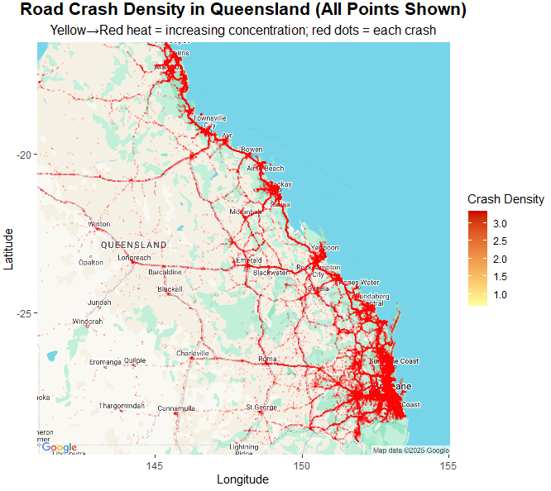
A Google “roadmap” underlay gives immediate geographic context, while two superimposed layers represent collision risk. Each of the approximately 390,000+ points show as a faint red dot, keeping full data coverage, while the same coordinates feed a kernel-density surface that ranges from yellow to dark red. By combining raw dots with a continuous heat ramp, viewers may quickly connect high-density locations to known routes and towns, recognizing that the hotspots are based on actual recorded accidents.
Visually, a single red ribbon runs down from Cairns to the Brisbane-Gold Coast region, indicating Queensland’s principal crash route. Secondary hotspots exist around Bundaberg, Toowoomba, and Emerald, linked by thinner red lines that follow inland roadways. West of ~145° E, the image fades to pale yellow, with faint traces along the highways and low crash density. These patterns emerge simply from traffic exposure, coastal highways transport, visitors, and SEQ congestion, combined with multilane configurations, increases crashes.

Crash severity each year
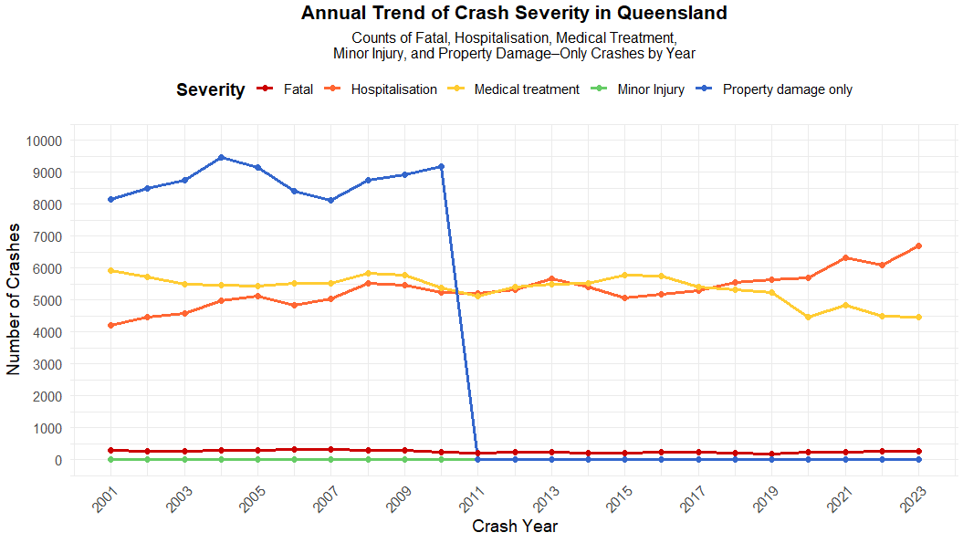
A five-line chart, with each line a different severity, allows users to compare trends across a single time axis. Fatalities are in red, hospitalizations in orange, medical treatment in yellow, minor injuries in green, and property damage-only crashes in blue. Dots mark annual count, and grid aids in value estimation. All series share y-axis revealing magnitude gaps, with hundreds of fatalities to thousands of property damage instances.
From 2001 to 2010, three tiers dominated. Property damage (~9500), medical treatment (~5000), and hospitalization (~5500). The number of fatalities and minor injuries in crashes remains below 300 and 100, respectively. In 2011, property damage events decreased to nearly nil and remained stable. Following 2015, medical treatment declined but hospitalizations increased, increasing by 2020 and peaking in 2023. Fatalities remain steady, and minor injuries stays minimal.
The 2011 property-damage collapse reflects a reporting defect, on December 31, 2010, police stopped lodging non-injury collisions, cutting ~40% of records (Queensland Government, 2024). Since then, true trends emerge, hospitalisations rise, safer vehicles minimize minor injuries, but increased traffic and distraction lead to more serious outcomes.

Crash severity by hour of the day
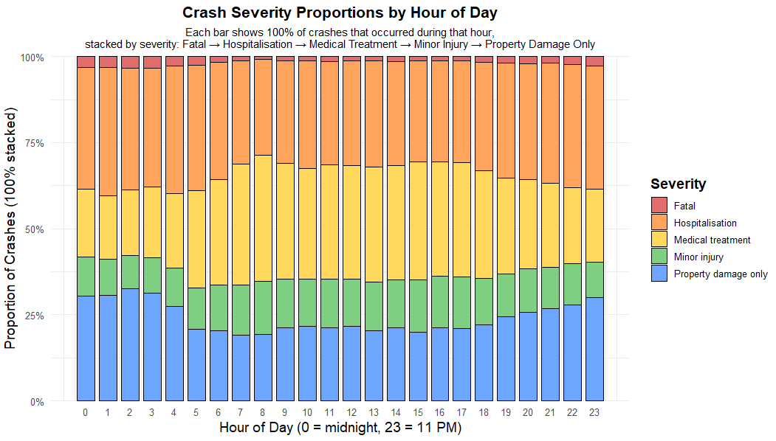
A 100%-stacked bar chart displays each hour (0-23) as a normalized column, with colors denoting severity red for fatality, orange for hospitalization, yellow for medical care, green for minor harm, and blue for property damage. This proportional approach eliminates volume swings and identifies which severities expand or reduce over the day.
Fatal crashes are the most common between midnight and 03h. Between 06-09h, medical-treatment events increased by roughly 40%, squeezing mild injuries. Hospitalizations increase between 14-20h, peaking at more than 30% around 18 hours. Minor injuries are more common during the daylight hours (10-16 h) but decrease after dusk. Late-night (22-23 h) property-damage-only reclaims the highest share.
After midnight, low volumes combine with multiple risks, resulting in the highest fatalities. From dawn until peak, traffic is packed but slow, resulting in multi-vehicle collisions that feed medical-treatment cases. Hospitalisations in the afternoon and evening coincide with commuter urgency. Minor injuries during the day are more visible. Late-night property damage spikes are probably caused by isolated runoffs on deserted highways.

Severity distribution across different crash types
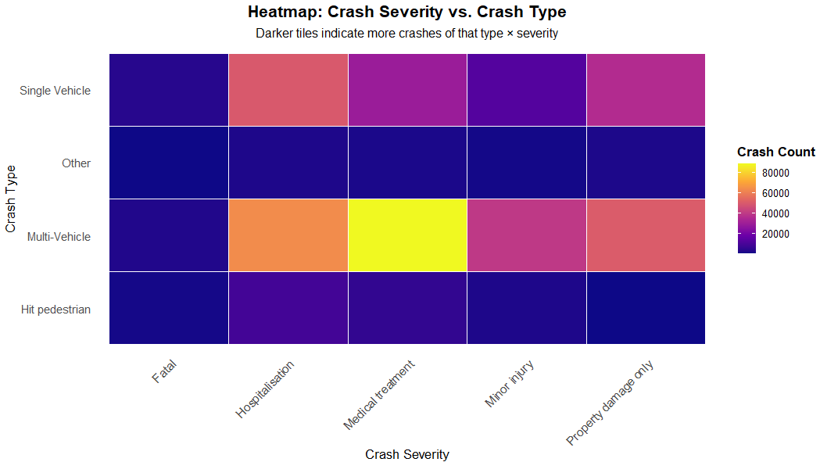
A heat map condenses crash type and severity into a single grid tinted with a Virdis-plasma gradient. This format instantly displays the highest-risk combinations.
Multi-vehicle crashes occupy the brightest cells across all severities, especially for hospitalisations and medical-treatment cases. Single-vehicle crashes rank second overall, with hospitalizations far surpassing property damage counts, indicating more serious harm. Pedestrian collisions, although rare, have a yellow fatal cell, emphasizing their disproportionate lethality. The “Other” category remains dark, contributing minimally to overall injuries.
These patterns reflect both exposure and mechanics. Multi-vehicle collisions are common on busy roads. High-speed runoffs and rollovers are the leading causes of single-vehicle hospitalizations, with injury severity determined by safety features and roadside hazards. Pedestrian fatalities are concentrated in urban locations with substantial vehicle-pedestrian contact, at higher speeds, a single collision is often lethal.

Trends & Anomalies
Crash counts remained flat-high until 2010, then fell 40% in 2011 (Queensland Government, 2024), before rising again until 2015 as population, traffic, and phone distraction increased. The density chart identifies a coastal corridor the Highway and SEQ conurbation while inland collisions are concentrated only in regional centres. Hospitalizations increase but medical-treatment cases decrease after 2015, indicating stricter triage or stronger impact factors. Fatalities occur around midnight 04h and 20-23h, when a lack of emergency coverage aggravate harm, property damage increases during slow afternoon traffic hours. The crash-type heat map reveals that multi-vehicle occurrences account for the majority of total trauma, while single-vehicle crashes are more likely to result in hospitalization, and uncommon pedestrian hits account for the highest fatality rate. Action priorities emerge, including tightening speed and enforcement along the coastal spine, focusing nighttime drink-drive and fatigue police, and incorporating pedestrian safety measures into urban design.

Ethical Principles Applied
Accuracy and Transparency - All charts use the complete public file, cleaning methods are specified, axes are linear, and the LOESS smoother is dotted to see both raw and smoothed numbers. Such traceability prevents accidental misrepresentation.
Privacy Protection - Even though the data is public, specific points may identify individuals. Maps thus show blurred density or faint dots, with no street-level drilldowns, meeting modern governance standards while protecting crash victims.
Clarity over exaggeration - Colour-blind-safe palettes are scaled to true counts, with red denoting fatalities but not enormous. Avoiding major distortions preserves the focus on true risk patterns and prevents policy overreaction.

Conclusion
Two decades of crash data were distilled into five clear visuals. The time-series shows steady volumes until a reporting change in 2011 cuts totals by ~40 %, followed by a gradual rise to early-2000s levels. A kernel-density map pinpoints the Bruce Highway and south-east corridor as dominant hotspots. Severity charts reveal that property-damage and medical-treatment crashes form the bulk, late-night hours carry the highest fatal share, and multi-vehicle or pedestrian events generate the gravest outcomes.
Actionable steps emerge direct policing and education to night-time, multi-vehicle settings; upgrade engineering along the coastal spine; and treat pre- and post-2011 data separately in evaluations. Transparent methods, privacy-safe mapping and unbiased colour scales keep the analysis ethical and trustworthy. Future work linking crashes to exposure, weather and driver profiles can refine these insights and further reduce Queensland’s road-safety burden.

References
- Queensland Government (2024, April 29). Crash data from Queensland roads. Queensland Government. https://www.data.qld.gov.au/dataset/crash-data-from-queensland-roads

